Name:_______________________________________________________

PART OF PC

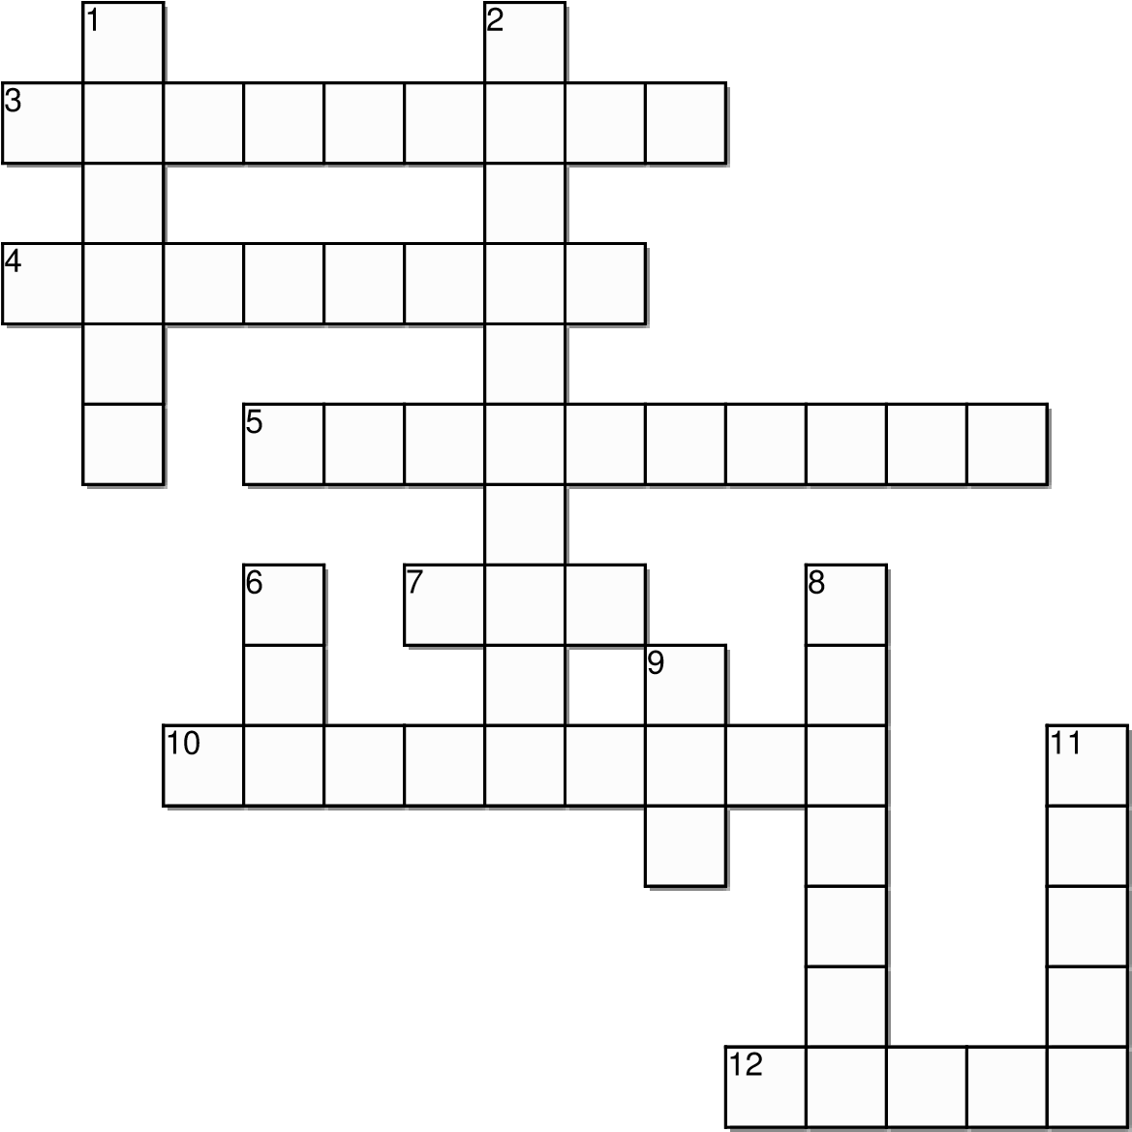
FILL THE CROSSWORD ANSWERS TO TRANSLATE ENGLISH

Horizontal
- DISCO DURO
- TECLADO
- MONITOR
7. READ ONLY MEMORY
10. IMPRESORA
12. UNIDAD DE CD
Created on TheTeachersCorner.net Crossword Maker

Vertical
- CAMARA
- MICROFONO
6. RANDONN ACCES MEMORY
- HARDWARE
- MEMORIA
11. RATON

